Assignment – 3

**By: Atharva Sachin Tilak**

Using GIT COMMIT Command

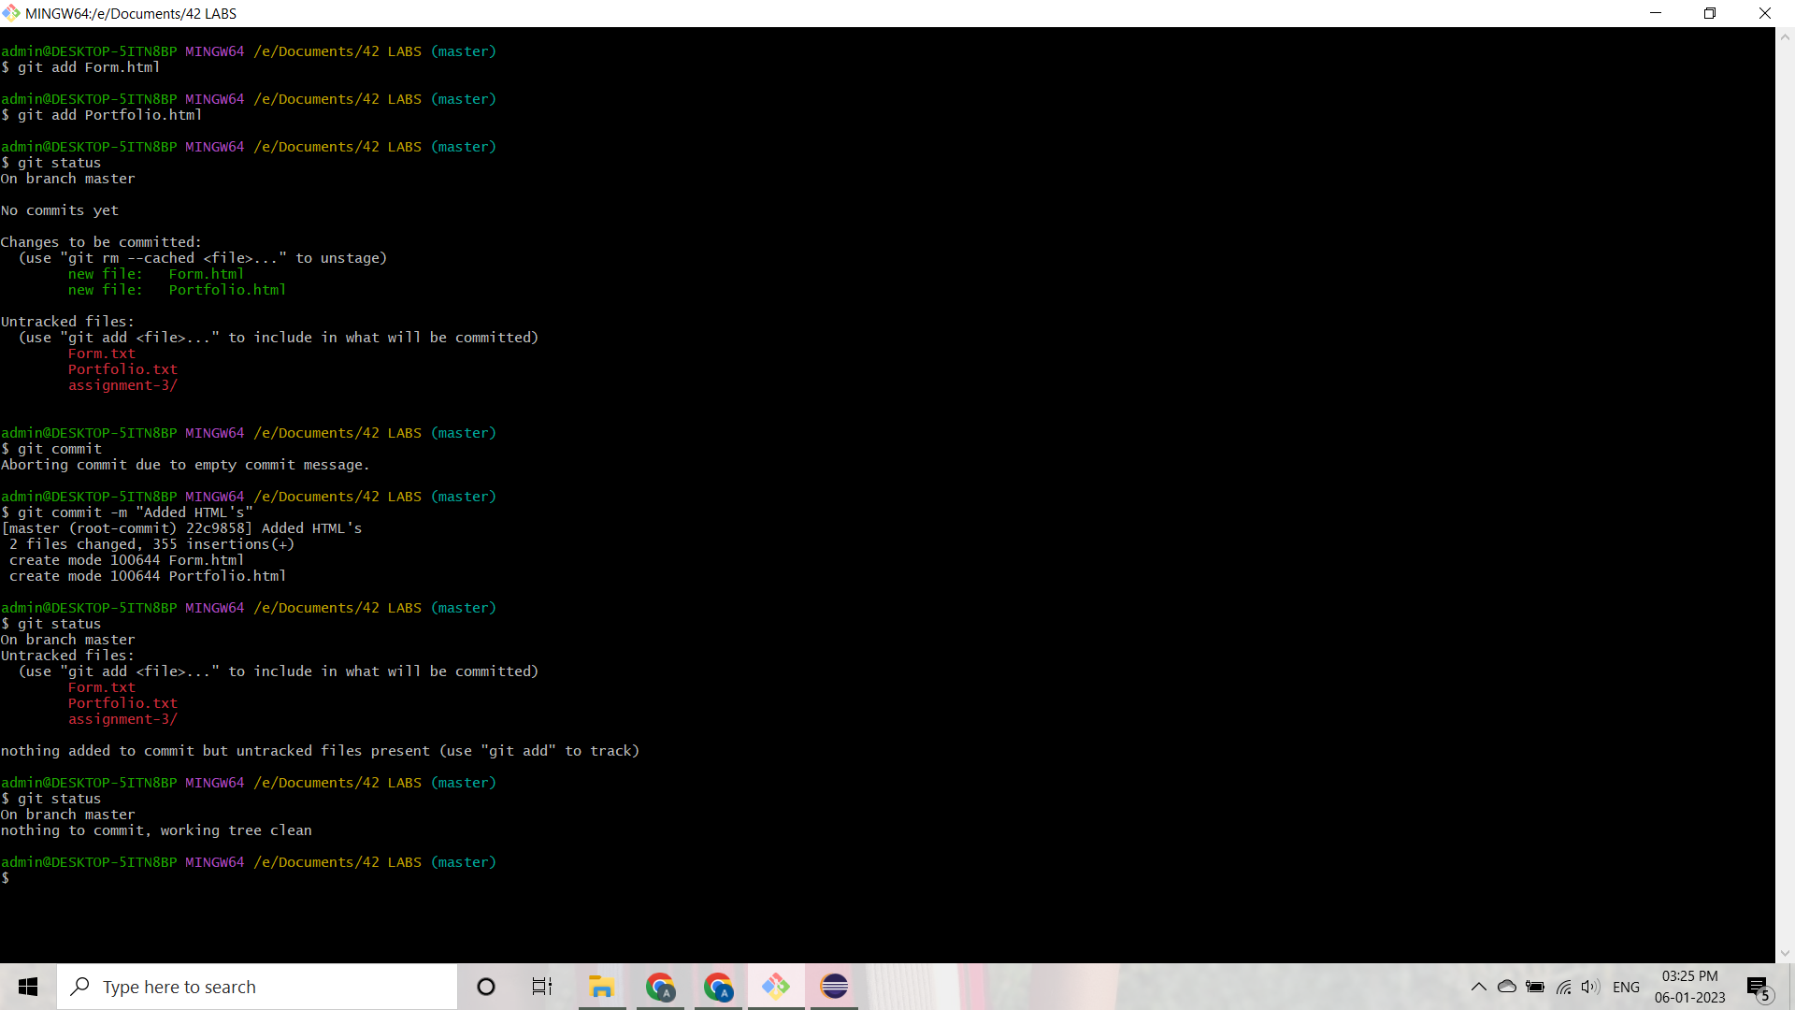

GIT PUSH and CLONE Command

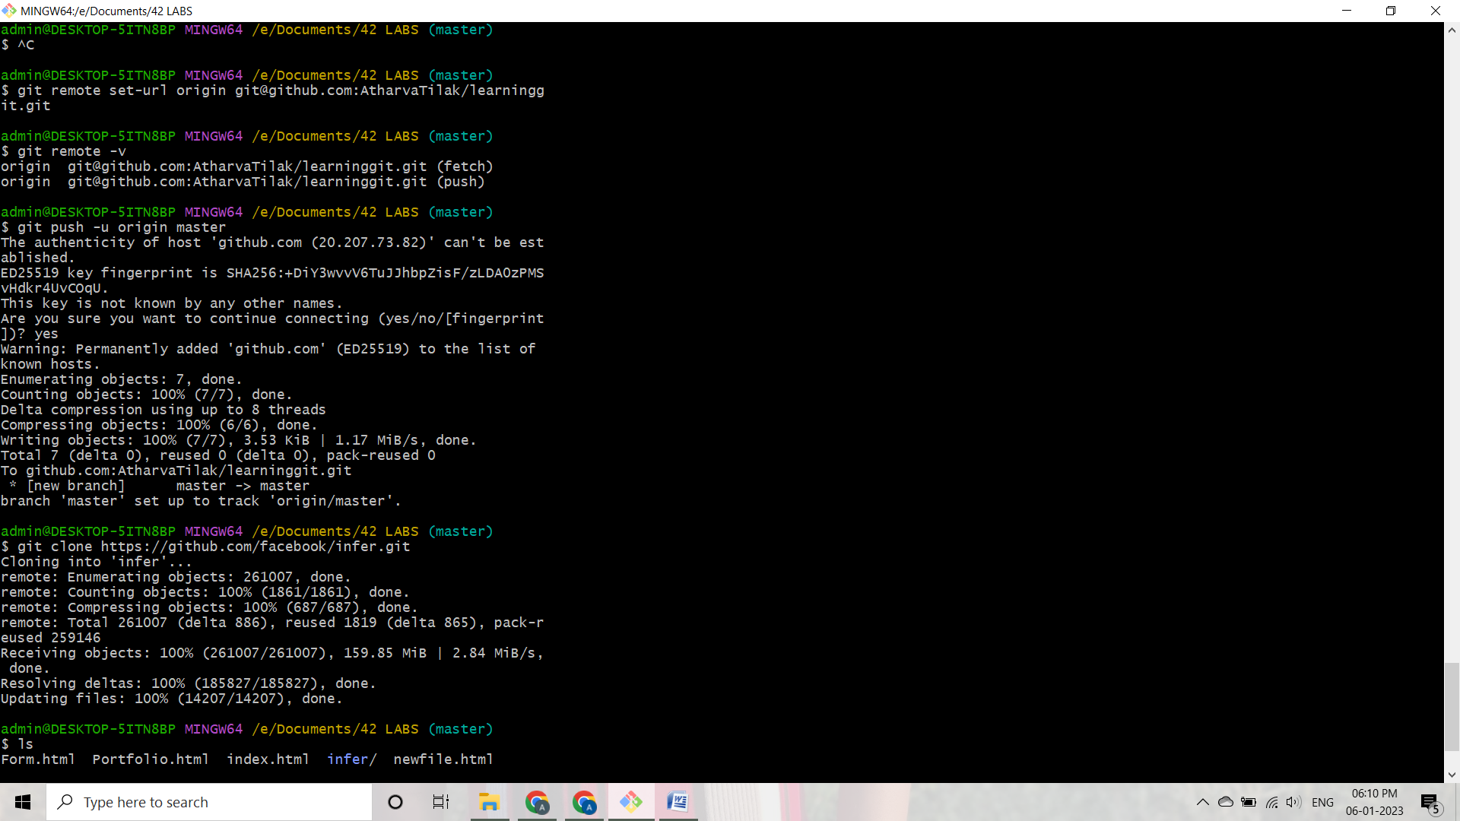

Using GIT PULL Command

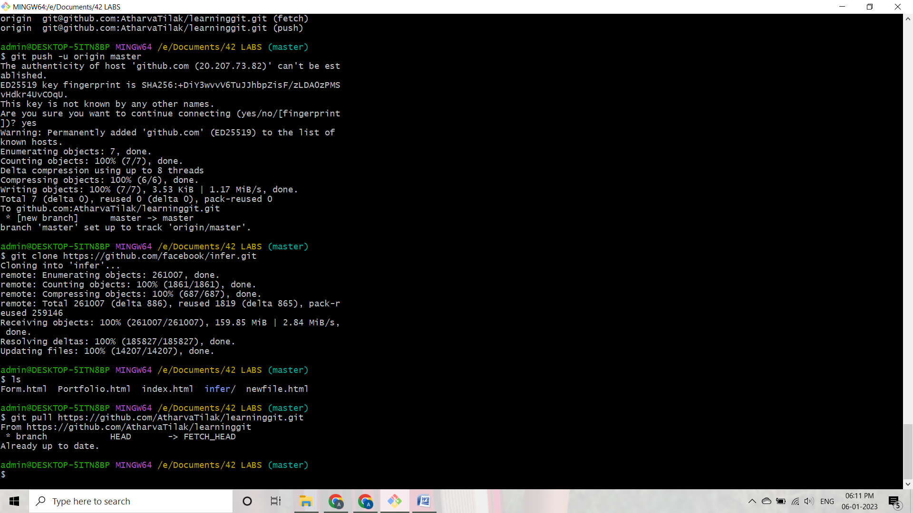

Using GIT BRANCH CREATION, BRANCH CHECKOUT and BRANCH MERGE Commands

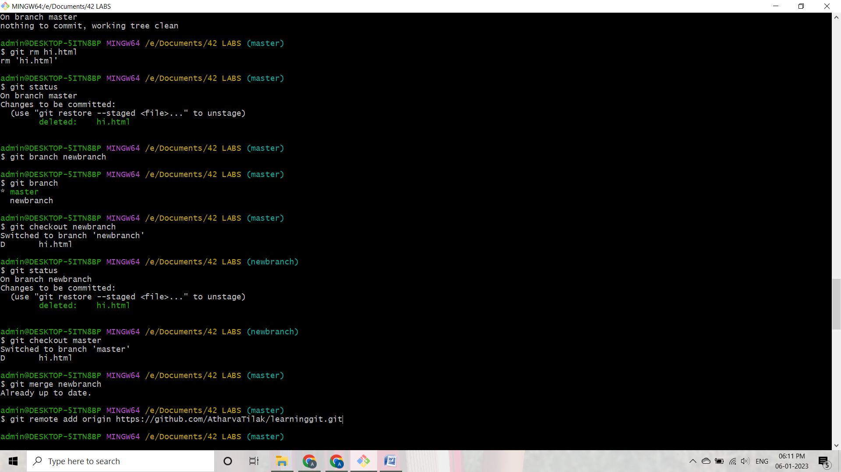

Using GIT PUSH to push the second branch into the repository

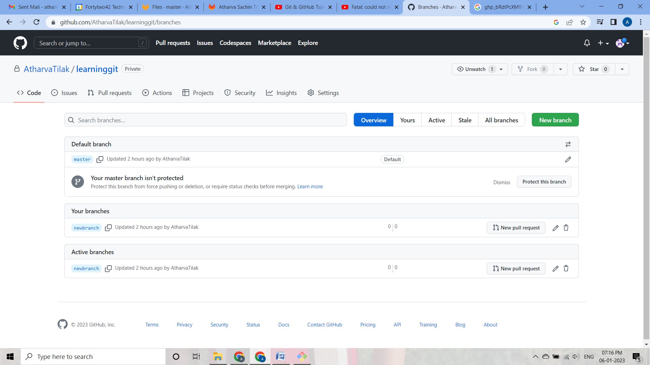

Created Repository on GITLAB

